New York Hospitals Prescribing Fruits, Veggies
By ABC News
Jul 27, 2013 6:00am
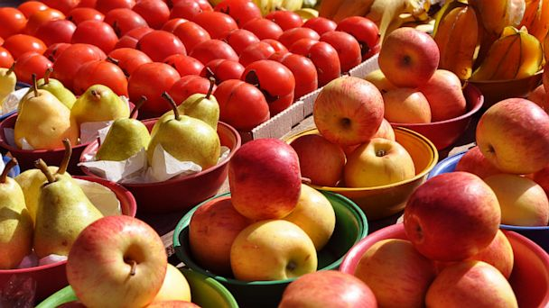Two New York hospitals are writing prescriptions for fresh produce. (Image credit: Getty Images)
Dr. Lisa Bajpayee reports:
An apple a day keeps the doctor away, so the saying goes. But for many living in New York City, that apple might come by prescription.
Two of the city’s hospitals — Lincoln Medical Center and Harlem Hospital — have joined a national experiment: the Fruit and Vegetable Prescription Program, or FVRx for short. The hospitals serve some of New York’s lower-income families. And according to Wholesome Wave, the organization spearheading the experiment, those families face the biggest hurdles when it comes to healthy eating.
For a Healthier Diet, Go Wild
The prescriptions come in the form of “health bucks” — coupons — $1 per day for each member of the family. That means a family of four would get $28 worth of coupons per week to be used at local farmers’ markets for fresh fruits and vegetables.
The program has seen a success in other metro areas, including Boston.
“It was a great way to start the conversation about eating healthy,” said Dr. Suki Tepperberg, lead physician for the program at Codman Square Health Center in Boston. “It motivated families to make a change. It even motivated families to make clinic appointments and to keep their appointments because they knew they were getting fruits and vegetables.”
“By the end of it,” Tepperberg added, ”more kids ate fruits and vegetables.”
Hungry Shoppers Eat Worse All Week Long, Study Finds
New York joins seven other states testing the Wholesome Wave plan. According to the organization’s end-of-market survey, participants reported a 93 percent increase in fruit and vegetable consumption in 2012. And it seems to be having an effect on health: 37.8 percent of child participants decreased their body mass index, or BMI.
“This looks like an excellent program,” said Dr. Donald Hensrud of the Mayo Clinic. “Increasing fruit and vegetable intake is associated with decreased risk of heart disease, cancer, obesity and even overall mortality.”
Cost is one of the biggest barriers to increasing fruit and vegetable consumption. But Hensrud said “behavioral inertia” — the tendency to eat what we’re used to eating — also stands in the way.
“Change is sometimes difficult, including eating new foods,” he said.
‘Self-Medicating’ With Fruits and Vegetables
Even if you are not in a place where prescriptions for fruits and vegetables have begun, there are affordable ways to increase your intake. United States Department of Agriculture (USDA) guidelines recommend 2 ½ cups of vegetables and 2 cups of fruit per day — a “dose” estimated to cost about $2.25 per day.
Here are a few tips that can help:
- Buy frozen: Research has shown that frozen fruits and vegetables have the same amount of nutrition as fresh produce. Frozen produce is often half the price of fresh produce and won’t go bad as quickly.
- Buy in season: Food grown in season is cheaper and tastes better.
- Grow your own: Growing your own fruits and veggies can be very satisfying. Not only is homegrown produce tastier but it’s cost-effective too.
- And buy in bulk: It’s cheaper to purchase fruits and vegetables such as apples, oranges, grapefruit, potatoes and onions by the bag, not by the piece. You’ll fill more lunch bags and cover more meals.

